**Practical No.1**

* Write a program for tokenization of given input.

**1)Sentense tokenization.**

**Input:**

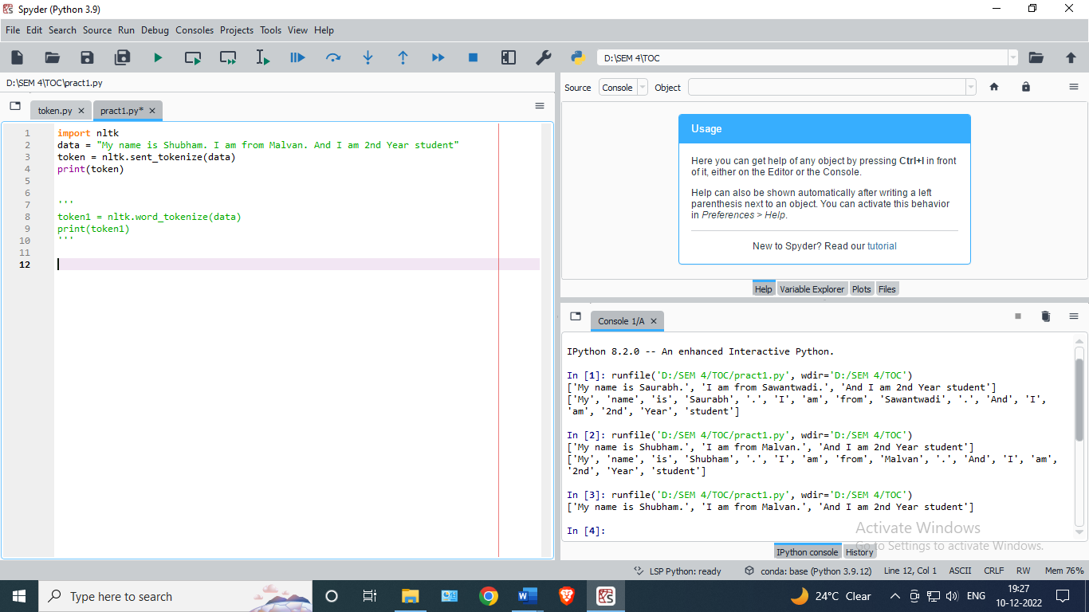

**Output:**

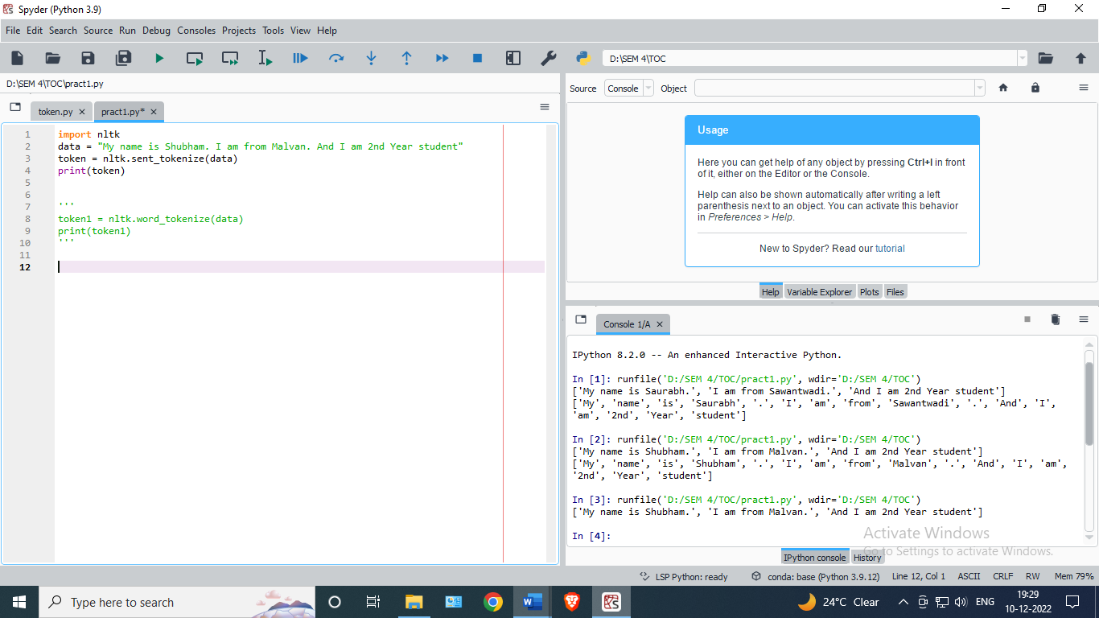

**2)Word tokenization:**

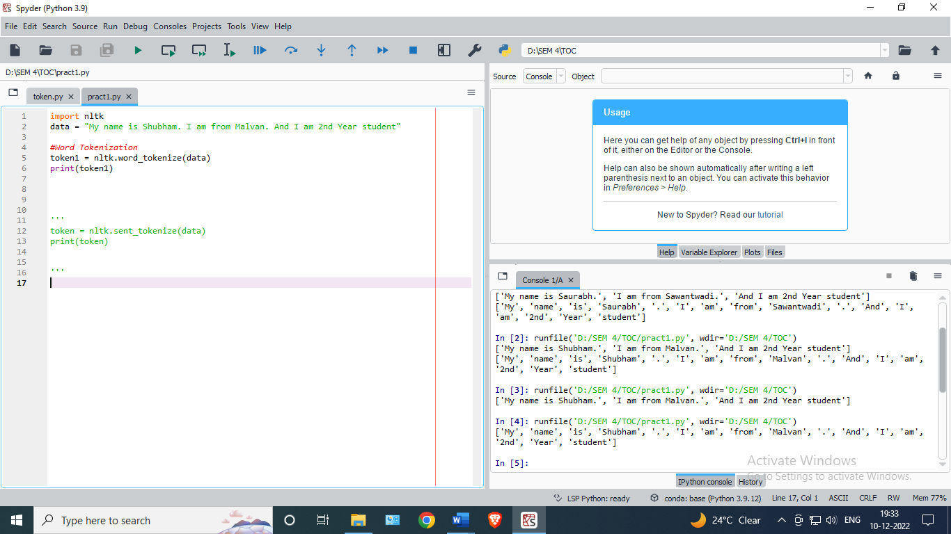

**Output:**

